AWS Certified Cloud Practitioner Practice Test 1 - Results
Return to review
Attempt 3
All knowledge areas
All questions

Question 1: Correct
Choose the benefits of using IaaS on the AWS cloud.
- ​
On-demand flexibility
(Correct)
- ​
Infrastructure management can be freely performed by users.
- ​
Cost is always cheaper than in the on-premises environment.
- ​
There is no need to implement security measures on the user's side.

Explanation
Option 1 is the correct answer. The advantage of the cloud is that you can instantly build, remove, and scale infrastructure such as servers on demand.

Option 2 is incorrect. In many cases, physical infrastructure management cannot be performed on the user side with AWS. AWS's Infrastructure control is inflexible and has a limited scope management opportunities available for users.
Option 3 is incorrect. The Cloud are often cheaper, but there is no guarantee that they will be cheaper. Extra costs can be incurred, such as when you overuse certain services.
Option 4 is incorrect. Using the cloud does not eliminate the need for security measures. It is necessary to take security measures according to the application service that you have built.

Question 2: Incorrect
Which EC2 instance purchase option will you use for a one-week campaign site?
- ​
Reserved Instance
- ​
Scheduled Reserved Instance
(Incorrect)
- ​
Spot instance
- ​
On-demand instance
(Correct)

Explanation
Option 4 is the correct answer. On-demand instance is a normal instance usage mode that charges a fee based on the time used. For a situation like this, where we will use the instance for only one week, it is desirable to use the on-demand instance type.
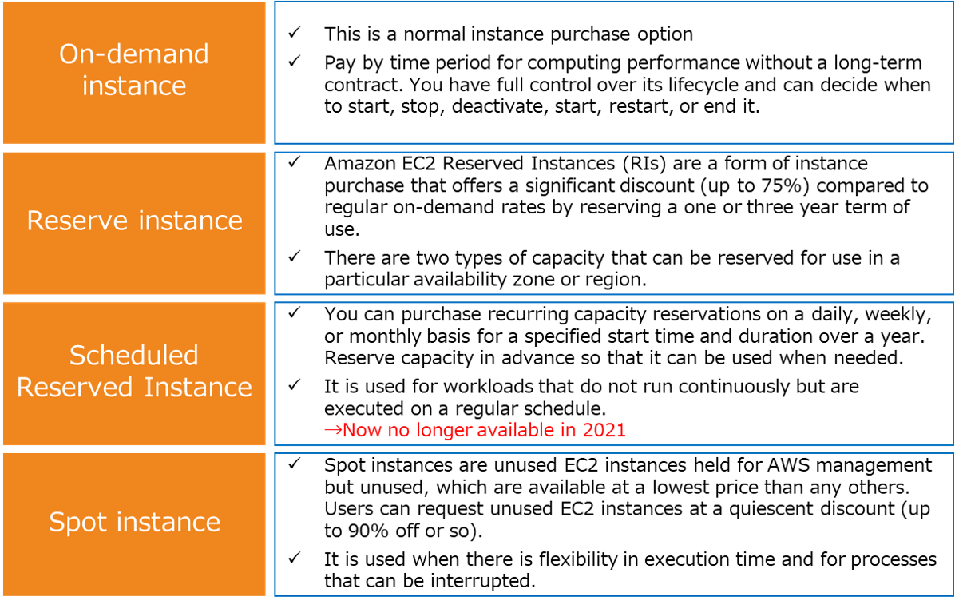
Option 1 is incorrect. Reserved Instance allow you to use an instance at a lower price than a normal EC2 instance by reserving it for a period of "1 year" or "3 years". Reserved Instances are intended for long-term use, so they are not suitable for one-week duration.
AWS does not have any capacity for purchasing Scheduled Reserved Instances or any plans to make it available in the future. To reserve capacity, use On-Demand Capacity Reservations instead. For discounted rates, use Savings Plans.
Option 2 is incorrect. Scheduled Reserved Instances can be purchased in three patterns: daily, weekly, and monthly. It is often used for requests such as batch processing only once a month. This is not suitable for an instance that will only be used for a week.
Option 3 is incorrect. Spot Instances are AWS-managed, unused EC2 instances available at a lower price than the on-demand price. Spot Instances can be temporarily used by users at a low price, but they may be suspended on the AWS side half-way through. For this situation, even though it is for temporary use on the campaign site, since the spot instance may be stopped unexpectedly, it should not be used for business that can not deal with this kind of irregularity. This is why it should not be chosen in this scenario.

Question 3: Correct
Choose the correct description for the characteristics of your Aurora database
- ​
Aurora can create up to 5 read replicas.
- ​
Aurora can only create read replicas for multi-configuration.
- ​
Read replicas can be configured with Multi-AZ.
(Correct)
- ​
Read replicas are automatically incremented by autoscale.

Explanation
Option 3 is the correct answer. Aurora can deploy read replicas across multiple AZs.

Option 1 is incorrect. Aurora can be configured with up to 15 read replicas, which can provide a significant amount of redundancy. On the other hand, RDS can only install up to 5 read replicas.
Option 2 is incorrect. Aurora can also be multi-mastered, making the master database itself redundant. Aurora Multi-Master is a highly available cluster configuration that allows writing to multiple nodes. Aurora can configure multi-masters across multiple AZs within a region.
Option 4 is incorrect. Read Replica manually determines the number of installations. However, with multi-cluster, it is possible to scale the cluster automatically.

Question 4: Correct
What must the user do if we wish to perform a penetration test on a web application hosted on an EC2 instance?
- ​
AWS support personnel will perform the test based on the user's test request.
- ​
The user conducts the test after applying for permission to test with AWS support.
- ​
Penetration test is prohibited because AWS ensures security.
- ​
The user is free to perform the test.
(Correct)

Explanation
Option 4 is the correct answer. In the AWS shared responsibility model, security for EC2 instances is the responsibility of the user, and penetration testing for EC2 instances can be freely performed by the user. Therefore, users can test EC2 instances without applying or permitting AWS.

Question 5: Incorrect
In the AWS CLI initial settings, select one of the following setting items that is not required.
- ​
Secret access key
- ​
Access key
- ​
Region
(Incorrect)
- ​
Multi-factor authentication
(Correct)

Explanation
Option 4 is the correct answer. When you start using the AWS CLI, use the aws configure command to set up your AWS CLI installation. When you enter this command, the AWS CLI prompts you for four types of information (access key, secret access key, AWS region, and output format) and saves them in a profile (a collection of settings) named default. Therefore, Multi-factor authentication is not one that is required.

Question 6: Correct
Choose the correct description of the features of multi-account management with AWS Organizations.
- ​
This feature allows cross-account management of IAM.
- ​
This feature allows you can reduce S3 costs by consolidating the storage volumes of each account.
(Correct)
- ​
This feature allows you to set the billing ratio according to each AWS account.
- ​
This feature allows cross-account infrastructure management using CloudFormation.

Explanation
Option 2 is the correct answer. AWS Organizations consolidated billing allows you to consolidate payments for multiple registered AWS accounts. Some AWS services, such as Amazon EC2 and Amazon S3, can take advantage of the volume price hierarchy. This is the price setting in which the service price range becomes cheaper as the amount and time used increases. The consolidated billing feature of AWS Organizations allows you to consolidate the usage volumes of each AWS account, which may reduce costs like this.

Option 1 is incorrect. AWS Organizations does not have the ability to perform IAM management. AWS Organizations uses SCP instead of IAM policies.
Option 3 is incorrect. AWS Organizations does not have the ability to set a billing weight for each account.
Option 4 is incorrect. AWS Organizations does not have the ability to perform cross-account CloudFormation infrastructure management.

Question 7: Correct
Choose the correct description for how we can perform an EBS volume data backup.
- ​
Create a replica of EBS
- ​
Set up automatic backup of EBS volumes.
- ​
Set up DML for EBS and schedule backups.
- ​
Take an EBS snapshot.
(Correct)

Explanation
Option 4 is the correct answer. You can ensure a backup of your EBS volume by taking a snapshot of your EBS volume. EBS snapshots are incremental backups. That is, the first snapshot takes a backup of all the data, but subsequent snapshots only store blocks on the device that have changed since the last snapshot. This minimizes the time required to take a snapshot and saves storage costs by not replicating data.
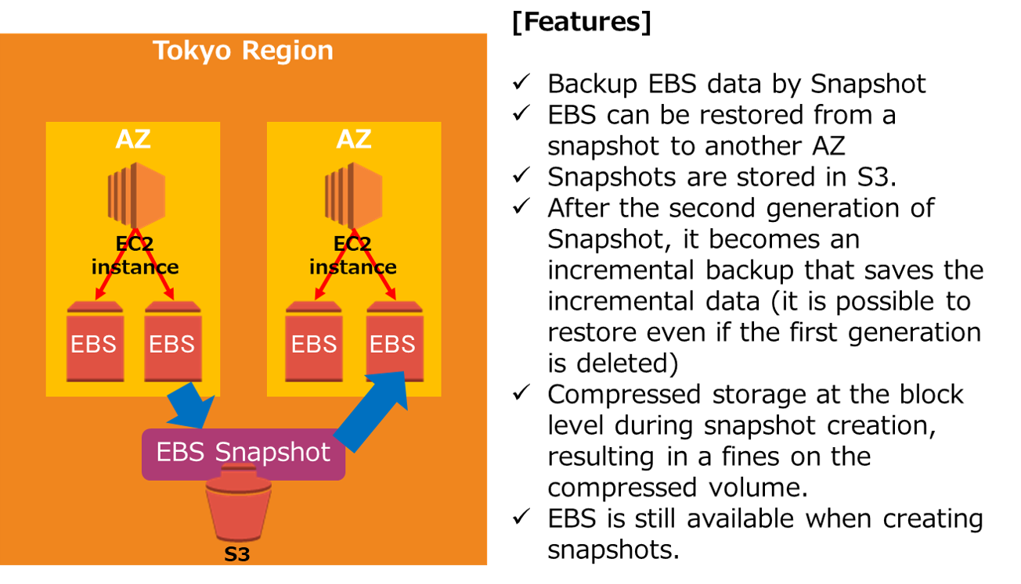
Options 1 and 2 are incorrect. You must use the snapshot feature to make a backup of your EBS volume. Replicas and automatic backups are not available on EBS.
Option 3 is incorrect. You can schedule snapshot acquisition by using DML, but it is not an essential backup method, only an optional one.

Question 8: Correct
I want to utilize high-speed cache processing for RDS. Which service should I use?
- ​
Redshift
- ​
ElastiCache
(Correct)
- ​
S3 Transfer Acceleration
- ​
Aurora

Explanation
Option 2 is the correct answer. By using Amazon ElastiCache, you can build a linkage that keeps RDS queries in the cache for high-speed access. Amazon ElastiCache is an in-memory datastore type high-speed cache database service that uses open source Redis and Memcached.
You can use this DB to retrieve data from a high-throughput, low-latency in-memory data store to build applications that handle large amounts of data or improve the performance of existing applications.
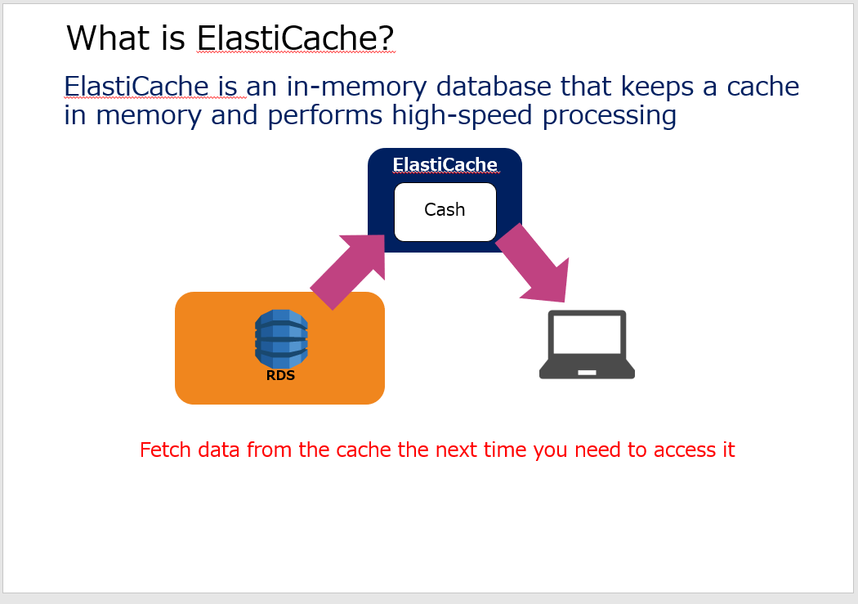
Option 1 is incorrect. Redshift is a data warehouse that runs on AWS. Redshift cannot work with RDS to perform high-speed processing.
Option 3 is incorrect. S3 Transfer Acceleration is a function that enables high-speed transfer to S3 data. It has nothing to do with RDS cache usage.
Option 4 is incorrect. Aurora is a relational database compatible with MySQL and PostgreSQL. You can achieve faster performance than regular RDS, but ElastiCache is better suited for high-speed data processing linked with RDS.

Question 9: Correct
Select the service that should be used to perform a linkage function, ensuring communication between components.
- ​
SES
- ​
API Gateway
- ​
Lambda
- ​
SQS
(Correct)

Explanation
Option 4 is the correct answer. Amazon SQS is a fully managed service that creates and manages message queues. SQS can send and receive messages between software components, and can implement task linkage and parallel processing between components. This mechanism improves overall system fault tolerance by allowing components to be separated and processed independently. All queue messages are stored redundantly across multiple Availability Zones so that they are not lost.

Option 1 is incorrect. Amazon SES is an email service that enables you to implement email functions in applications, etc., and is not used for linking components.
Option 2 is incorrect. Amazon API Gateway is a fully managed API management service that makes it easy to create, distribute, maintain, monitor, and protect APIs. This is also not used for coordination between components.
Option 3 is incorrect. With AWS Lambda, you can run your code without provisioning or managing servers. This is not a service used to send and receive messages between components.

Question 10: Incorrect
You want to prevent downtime in a region for applications under development to near zero, even in the case of a large-scale disaster. Which deployment method should you choose?
- ​
Multi AZ configuration
(Incorrect)
- ​
Multi-region configuration
(Correct)
- ​
Multi-VPC configuration
- ​
Multi-subnet configuration

Explanation
The AWS Global Infrastructure is centered around Regions and Availability Zones (AZs). Each AWS Region is a separate geographical area. Each AWS Region is further made up of multiple separate locations called Availability Zones. By using a multi-AZ configuration, it is possible to build a highly redundant and highly available system that can continue to operate even if one AZ is stopped, but it cannot be handled if a failure occurs over the entire region. ..
In this scenario, it is necessary to prevent downtime in the event of a disaster, and it is necessary to configure it even for region failures. You can further increase redundancy and fault tolerance by preparing a configuration that sets up the secondary configuration on standby across multiple regions. Therefore, option 2 multi-region is the correct answer.

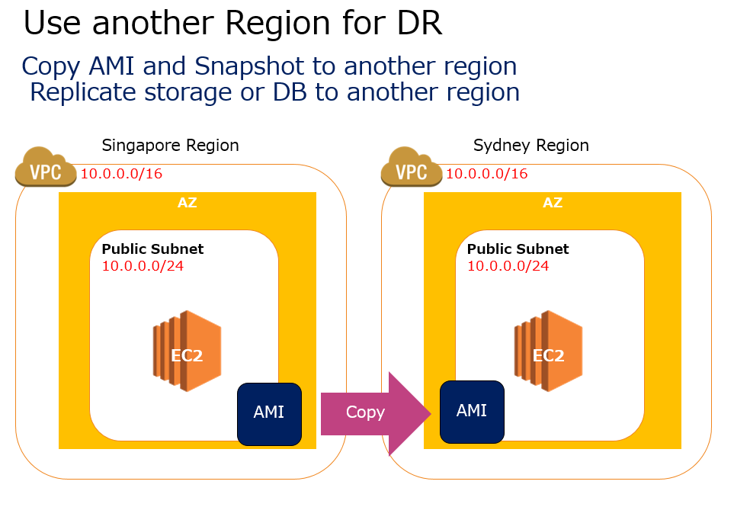

Question 11: Correct
Malware delivery to your AWS resources has been confirmed. Knowing this, which AWS department should you contact?
- ​
Contact AWS Security Team
- ​
Contact AWS Concierge Support
- ​
Contact AWS Customer Service Team
- ​
Contact AWS Trust & Safety team
(Correct)

Explanation
Option 4 is the correct answer. AWS Trust & Safety team can assist you when AWS resources are used to engage in the following types of abusive behavior:
・Spam: You are receiving unwanted emails from an AWS-owned IP address, or AWS resources are used to spam websites or forums.
・Port scanning: Your logs show that one or more AWS-owned IP addresses are sending packets to multiple ports on your server, and you believe this is an attempt to discover unsecured ports.
・DDoS attacks: Your logs show that one or more AWS-owned IP addresses are used to flood ports on your resources with packets, and you believe that this is an attempt to overwhelm or crash your server or the software running on your server.
・Intrusion attempts: Your logs show that one or more AWS-owned IP addresses are used to attempt to log in to your resources.
・Hosting objectionable or copyrighted content: You have evidence that AWS resources are used to host or distribute illegal content or distribute copyrighted content without the consent of the copyright holder.
・Distributing malware: You have evidence that AWS resources are used to distribute software that was knowingly created to compromise or cause harm to computers or machines on which it is installed.

Question 12: Correct
Which AWS team can help you plan and build your solution according to best practices?
- ​
TAM
(Correct)
- ​
IEM
- ​
ISM
- ​
TSM

Explanation
The AWS Support Enterprise Plan offers a Technical Account Manager (TAM). TAM provides users with a variety of recommendations and guidance to help them plan and build solutions according to best practices and keep their AWS production environment healthy. Therefore, option 1 is the correct answer.
The other options are incorrect.

Question 13: Correct
Please select the correct description for the data you saved in Amazon S3.
- ​
You can access the S3 object via a URL.
(Correct)
- ​
Enabling public access in your bucket policy is required to allow you to access S3 objects from the Internet.
- ​
You can store virtual unlimited size objects into S3.
- ​
Auto scaling is applied to the storage area of S3.

Explanation
Option 1 is the correct answer. Amazon S3 allows you to access your bucket with both virtual host-style URLs and path-style URLs

Option 2 is incorrect. To allow access to an object from the Internet, disable public access block and then allow public access to the object with an object ACL. By default, bucket policy settings are not always required.
Option 3 is incorrect. Amazon S3 objects can be as small as 0 bytes and as large as 5 terabytes. The size is not unlimited.
Option 4 is incorrect. Amazon S3 does not have autoscaling capabilities. S3 is offered as a managed service with no capacity limit.

Question 14: Correct
It is desirable to design AWS based on the principles of a flexible and elastic cloud architecture. How do you achieve this architecture?
- ​
Implement a configuration that automates scaling according to demand.
(Correct)
- ​
Configure an architecture that links loosely coupled components.
- ​
Build serverless applications.
- ​
Code and share your infrastructure.

Explanation
Option 1 is the correct answer. The concept of elasticity includes the ability to automatically expand or contract resources based on changing demand. Auto Scaling is a typical service that manages this function on AWS. By configuring an architecture that incorporates Auto Scaling, you can automate the process of adding or removing Amazon EC2 instances as demand increases or decreases.
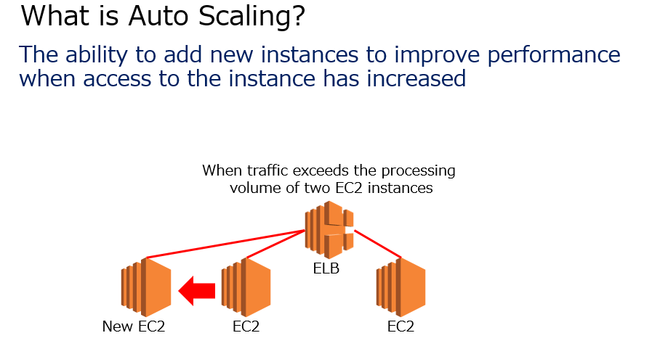
Option 2 is incorrect. Loose coupling between components reduces interdependence between application components and reduces risk. This is not flexibility, but an architecture that improves performance and availability.
Option 3 is incorrect. A serverless application is an application that uses Lambda functions without using server services such as EC2. This is not flexibility, but cost optimization and reliability.
Option 4 is incorrect. Infrastructure coding is a response used to achieve environmental automation.

Question 15: Correct
Select the combination of services you should use to keep track of your billing limit in a timely manner.
- ​
CloudWatch & SNS
(Correct)
- ​
CloudWatch & SQS
- ​
CloudWatch & Amazon MQ
- ​
Billing dashboard

Explanation
Option 1 is the correct answer. CloudWatch allows you to set a billing alarm that triggers a notification when your usage charges exceed a set threshold. This CloudWatch alarm can also set SNS based on your email address as a notification function. This allows you to set up real-time email notifications.

SQS and MQ are not available for alarm notification settings. Therefore, options 2 and 3 are incorrect.
Option 4 is incorrect. There is no service called billing dashboard. AWS Billing and Cost Management is a service used to pay AWS invoices, monitor usage, and analyze and manage costs.

Question 16: Correct
What should I do to minimize billing for EC2 instances of applications that I haven't used for months?
- ​
Stop the instance.
- ​
Create an AMI and terminate the instance.
(Correct)
- ​
Use Spot Instances.
- ​
Take a snapshot of EBS.

Explanation
Option 2 is the correct answer. By acquiring the AMI and then deleting the instance, it is possible to restore the EC2 instance and reproduce the application configuration when using it again. This is the best response for minimal cost.

Option 1 is incorrect. Even if you stop the instance, the EBS volume remains, so you will be charged for it. This does not meet the minimum cost requirement.
Option 3 is incorrect. By using Spot Instances, you can reduce the cost of your instances, but it does not meet the requirement to reduce the cost of your current instances. If you want to use Spot Instances, it must be a use case suitable for Spot Instances.
Option 4 is incorrect. If you just take a snapshot of EBS, you will continue to be charged because your instance is still in use.

Question 17: Correct
Choose the service that allows you to define provisioning and configuration rules and monitor their deviations.
- ​
AWS Config
(Correct)
- ​
Amazon Inspector
- ​
AWS Trusted Advisor
- ​
AWS Systems Manager

Explanation
Option 1 is the correct answer. AWS Config continuously audits and evaluates whether your AWS resource settings meet corporate policies and compliance. Config allows you to define rules for provisioning and configuring AWS resources. Any resource settings or configuration changes that deviate from the rules will automatically trigger SNS notifications to help identify compliance gaps. You can also leverage dashboards to visually display your overall compliance status and quickly identify non-compliance resources.
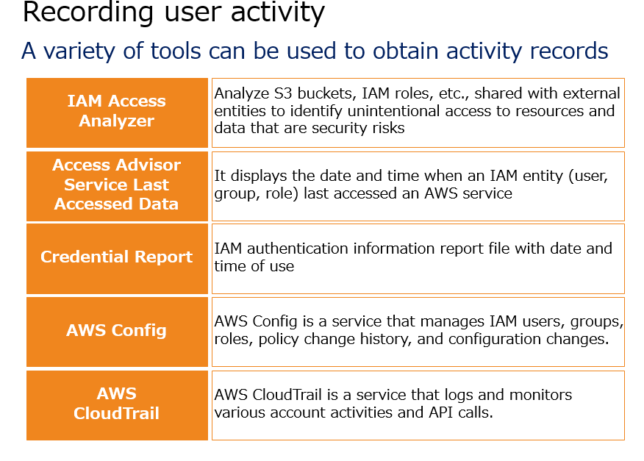
Option 2 is incorrect. Amazon Inspector identifies application vulnerabilities and deviations from best practices before deploying your application and during production operations. You can take advantage of this to increase the security of your applications deployed on AWS. It cannot define and monitor AWS resource provisioning or configuration rules.
Option 3 is incorrect. AWS Trusted Advisor scrutinizes the user's AWS environment from the five perspectives of "cost optimization," "operational excellence," "security," "reliability," and "performance Efficiency," and provides real-time notification of recommended settings. It is a function that will help you however It doesn't provide monitoring by defining rules for provisioning or configuring AWS resources.
Option 4 is incorrect. AWS Systems Manager is a service that allows you to visualize and control your infrastructure on AWS. It cannot define and monitor AWS resource provisioning or configuration rules.

Question 18: Correct
Choose a setting to protect your S3 data. (Select two.)
- ​
Delete the security key.
- ​
Enable encryption of stored data
(Correct)
- ​
Encrypt data before uploading.
(Correct)
- ​
Implement authority management according to IAM policy.
- ​
Set up an SSL certificate.

Explanation
If you want to protect the data used in S3, either encrypt the data when transferring it or encrypt the stored data. You can protect the data in transit by using SSL or client-side encryption to encrypt the data in transit. Option 5 is incorrect.
HTTPS (TLS) can be used to prevent potential attackers from using man-in-the-middle attacks or similar attacks done through eavesdropping or manipulating network traffic. To do this, use the aws: SecureTransport condition in your Amazon S3 bucket policy to allow only encrypted connections over HTTPS (TLS). It is a mistake to set the SSL certificate.
You can take the following actions to protect the stored data in S3.

By enabling server-side encryption, you can require Amazon S3 to encrypt your saved object and decrypt it when you download the object. Therefore, option 2 is the correct answer.
Client-side encryption encrypts the data on the client and then uploads the encrypted data to Amazon S3. In this case, the user manages the encryption process, encryption keys, and related tools. Therefore, option 3 is the correct answer.

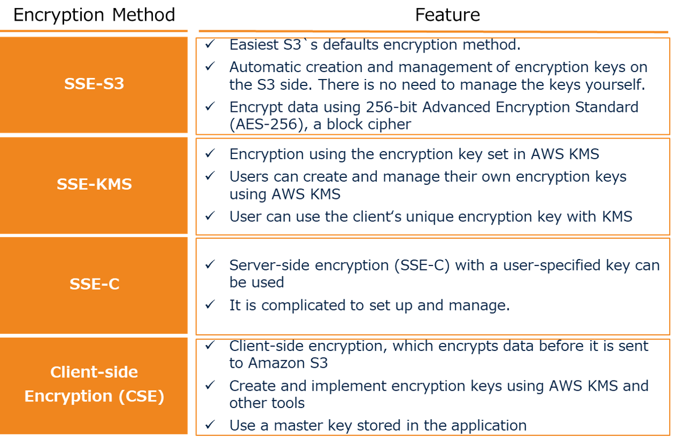

Question 19: Correct
Choose the correct description of how we can use AWS global infrastructure.
- ​
You can instantly implement global infrastructure deployments.
(Correct)
- ​
It is possible to automate the global expansion of infrastructure configurations.
- ​
Additional costs are required when deploying infrastructure globally using areas other than your own region.
- ​
It is necessary to have a separate AWS account for each region.

Explanation
Option 1 is the correct answer. AWS is a globally deployed cloud service that allows you to deploy infrastructure instantly in different regions around the world.

Option 2 is incorrect. The region where you deploy AWS resources must be set manually, and so automating global deployment is an not an appropriate description.
Option 3 is incorrect. There is no additional cost for global use necessarily. The cost differences will depend on the AWS resources you use.
Option 4 is incorrect. It is not always necessary to manage each region, and global services can be centrally managed in multiple regions. you can deploy services in multiple regions with one AWS account.

Question 20: Correct
Choose the correct description for Availability Zones.
- ​
All AZs are connected by a low latency link.
- ​
AZ consists of multiple data centers.
(Correct)
- ​
The number of AZ in a region range from 1 or more
- ​
AZ has multiple edge locations.

Explanation
Option 2 is the correct answer. One AZ consists of multiple data centers.

Option 1 is incorrect. Only AZs within the same region, but not all, are connected by low latency links. It is not connected to AZs in other regions.
Option 3 is incorrect. There are at least two AZs in the region.
Option 4 is incorrect. One AZ consists of multiple data centers. The edge location is installed separately from AZ.

Question 21: Incorrect
Select a service that verifies that your application on AWS has the proper security settings.
- ​
Amazon Inspector
(Correct)
- ​
Amazon CloudWatch
- ​
AWS Systems Manager
(Incorrect)
- ​
AWS GuardDuty

Explanation
Option 1 is the correct answer. With Amazon Inspector, users can evaluate and improve their security and compliance settings for applications that utilize AWS resources.
Amazon Inspector can automatically evaluate your application for exposures, vulnerabilities, and deviations from best practices. After evaluation, a detailed list is created showing the results in order of severity/priority. You can review this list directly, or you can review it in the detailed assessment report available through the Amazon Inspector console or API.
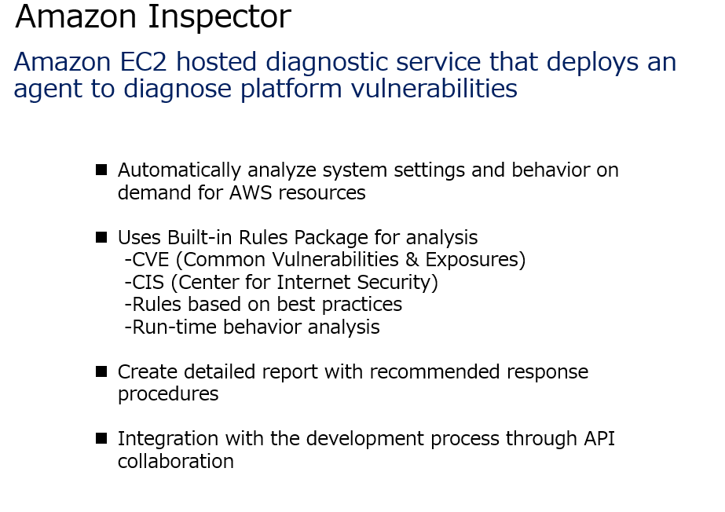
Option 2 is incorrect. CloudWatch provides data and actionable insights to monitor applications, optimize resource utilization in response to changes in overall system performance, and provide a comprehensive view of operational health. It is not possible to verify that the application has the proper security settings.
Option 3 is incorrect. AWS Systems Manager is a service that allows you to visualize and control your infrastructure on AWS. It is not possible to verify that the application has the proper security settings.
Option 4 is incorrect. Amazon GuardDuty is a threat detection service that continuously monitors malicious activity and malicious behavior. It is not possible to verify that the application has the proper security settings.

Question 22: Correct
What are the security benefits of storing data on AWS?
- ​
AWS personnel protect your data.
- ​
Users have full control over their data.
(Correct)
- ​
AWS staff can monitor the data contents.
- ​
Data protection is automatically implemented even if the user does not take data security measures.

Explanation
Option 2 is the correct answer. In AWS, all the data used in applications etc. can be completely controlled by the user. The AWS side does not have permission to access the data stored by the user.

Options 1 and 3 are incorrect. The AWS side does not have permission to access the user's data.
Option 4 is incorrect. Users are required to take measures such as data encryption.

Question 23: Incorrect
Please select the wrong description for a AWS data center.
- ​
AWS data centers perform third-party security audits.
- ​
Multiple data centers make up one AZ.
(Incorrect)
- ​
Users can use their data center to deploy AWS services.
- ​
AWS employees can access the data center.
(Correct)

Explanation
Option 4 is the wrong explanation, so it is correct. Even AWS employees are not even informed of the location of the data center except for specific data center workers or certain administrators. Therefore, this explanation is incorrect.

Option 1 is incorrect. AWS data centers perform third-party security audits to ensure security.
Option 2 is incorrect. One or more data centers make up one AZ.
Option 3 is incorrect. AWS OutPosts allows users to leverage their own data center to deploy AWS services.

Question 24: Correct
Choose the correct description for your EC2 instance pricing. (Select two.)
- ​
On-demand instances are charged for usage time in seconds or hours.
(Correct)
- ​
Prepaid is possible by using Reserved Instances.
(Correct)
- ​
Scheduled Reserved Instances can be charged once a week.
- ​
Spot Instances are available as a temporary resource with prepayment.
- ​
Dedicated Host can be prepaid.

Explanation
Option 1 is the correct answer. On-demand instances are correct because they are charged for usage time in seconds or hours, depending on the OS you configure.
Option 2 is the correct answer. Reserved Instances can be prepaid by booking and using for a period of 1 or 3 years.

Option 3 is incorrect. By using Scheduled Reserved Instances, you can set the usage time periodically such as weekly or monthly.
Option 4 is incorrect. Prepaid does not apply to Spot Instances.
Option 5 is incorrect. Prepaid does not apply to Dedicated Host.

Question 25: Correct
Select an AWS service or feature that connects between different regions.
- ​
VPC peering
- ​
Direct Connect Gateway
(Correct)
- ​
VPC Endpoint
- ​
AWS Managed VPN

Explanation
Option 2 is the correct answer. By using the Direct Connect gateway, which is a related function of Direct Connect, it is possible to connect regions in a wide band using a dedicated line.
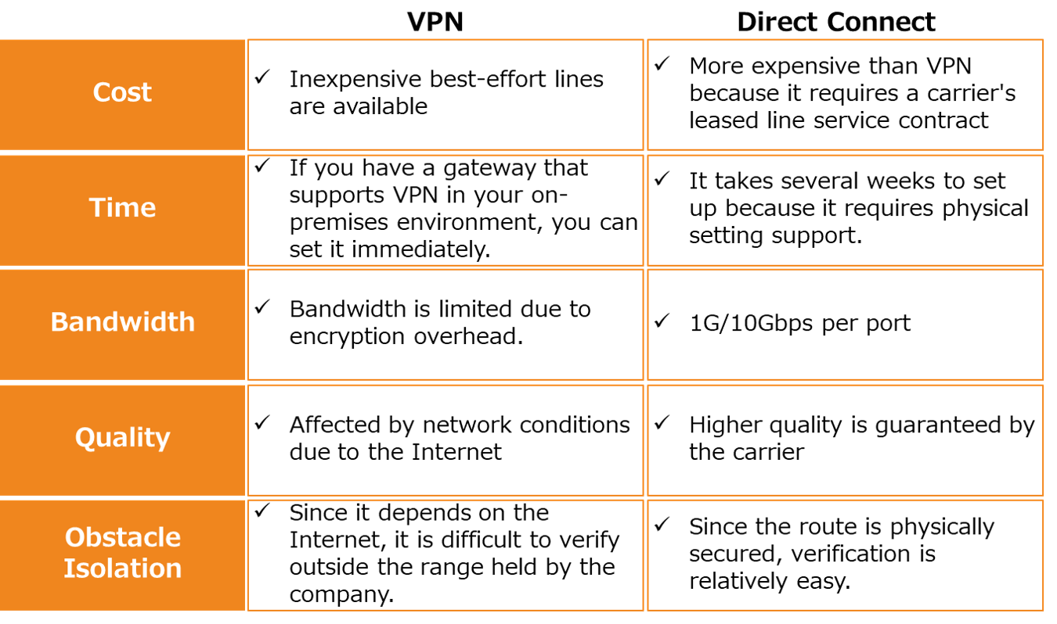
Option 1 is incorrect. VPC peering is only available for connections between VPCs.
Option 3 is incorrect. A VPC endpoint is an endpoint used to connect to services outside your VPC from inside your VPC.
Option 4 is incorrect. With AWS Managed VPN, you can configure a VPN connection between your on-premises environment and AWS. It is not used to connect between regions.

Question 26: Skipped
Select a service that allows you to know the usage costs of the service used by a specific user.
- ​
AWS Cost Categories
- ​
Cost Explorer
- ​
Billing and Cost Management Console Dashboard
- ​
AWS Cost and Usage Report
(Correct)

Explanation
Option 4 is the correct answer. AWS Cost and Usage Reports provide the most comprehensive cost and usage data, including metadata such as services, pricing, and bookings. The AWS Cost and Usage Report lists the usage of each service used by your account and its IAM users as hourly or daily line items, as well as tags activated for cost allocation.
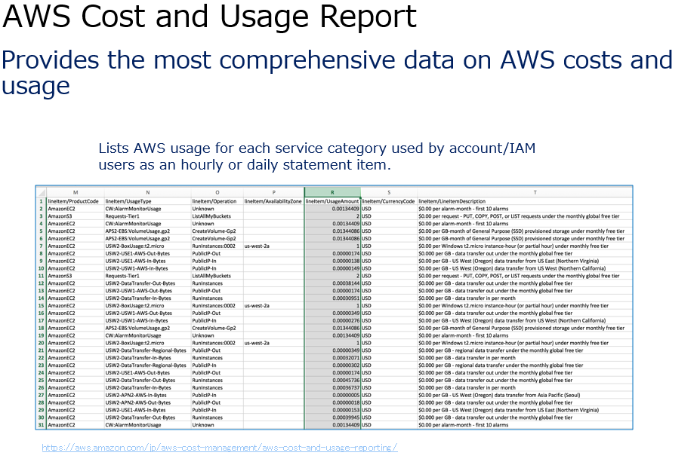
Option 1 is incorrect. AWS Cost Categories is a service that arbitrarily classifies cost usage. It allows users to define categorical rules and classify costs based on account or tag.
Option 2 is incorrect. Cost Explorer is a tool you can use to view and analyze costs and usage.
Option 3 is incorrect. On the Billing and Cost Management console dashboard, you can see a variety of graphs showing different details of AWS usage.

Question 27: Correct
Choose the correct description for the characteristics of a region.
- ​
There is no difference in AWS services in all regions.
- ​
There are differences in AWS service charges between regions.
(Correct)
- ​
Any region can be used.
- ​
Only regions close to the user can be chosen.

Explanation
Option 2 is the correct answer. The price of AWS services varies slightly depending on the region, and it is necessary to calculate the cost for each region. Therefore, option 2 is correct and option 1 is incorrect.

Option 3 is incorrect. Not all regions are available, and some regions are not open to the public, such as the Osaka local region and the region inside mainland China.
Option 4 is incorrect. Regions that are open to global use can deploy infrastructure from any country.

Question 28: Correct
Which is not the basic principle of the Well Architected Framework?
- ​
Reliability
- ​
Availability
(Correct)
- ​
Performance efficiency
- ​
Security

Explanation
AWS Well-Architected helps cloud architects build secure, high-performing, resilient, and efficient infrastructure for their applications and workloads. Based on five pillars :
・operational excellence
・security
・reliability
・performance efficiency
・cost optimization

AWS Well-Architected provides a consistent approach for customers and partners to evaluate architectures, and implement designs that can scale over time. Option 2 is correct because availability is wrong

Question 29: Correct
From the following services, select a service that cannot be reserved for purchase.
- ​
ElastiCache
- ​
DynamoDB
- ​
Redshift
- ​
RDS
- ​
S3
(Correct)

Explanation
Some AWS services have an option that allows you to select a discounted price based on the commitment that you will continue to use it for a certain period of time, such as 1 to 3 years. Reserved purchases include
・EC2 Reserved Instances
・RDS Reserved Instances
・ElastiCache Reserved Nodes
・DynamoDB Reserved Capacity
・Redshift Reserved Nodes.

There are no reserved purchases on S3. You pay for the amount of data you use.
Therefore, option 5 is the correct answer.

Question 30: Correct
You want to migrate 155TB of data in your on-premises environment to AWS. Which device combination will provide the most cost-effective migration?
- ​
Snowball ×２
- ​
Snowball Edge×２
(Correct)
- ​
Snowball Edge×１
- ​
Snowball ×１

Explanation
Option 2 is the correct answer. Snowball Edge can move 80TB of data capacity with one appliance, so you can transfer 155TB of data with two. Therefore, option 3 is incorrect because one unit is insufficient.
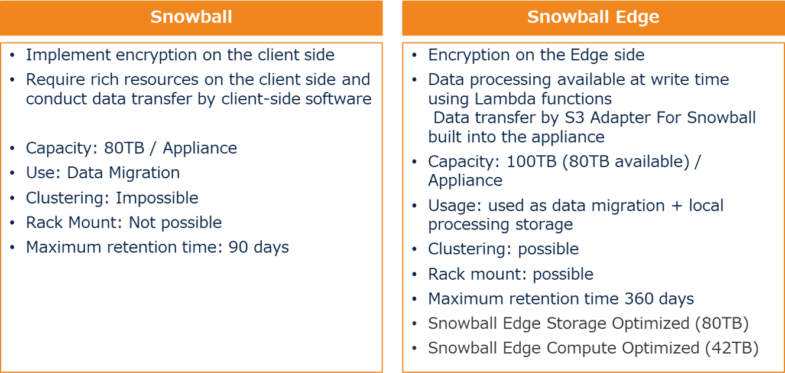
Options 1 and 4 are incorrect. .. The available space for Snowball (80 TB) is 72 TB. In other words, Snowball x 2 cannot migrate 155TB of data. Also, Snowball is currently not recommended for use.

Question 31: Incorrect
Select which CloudWatch settings are used to get detailed information from inside your EC2 instance. (Select two.)
- ​
Use CloudWatch events to get detailed information about EC2 instances.
- ​
Enable CloudTrail trail settings to link your EC2 instance trails to CloudWatch.
(Incorrect)
- ​
Set up CloudWatch Logs to get internal information about your EC2 instance.
- ​
Install CloudWatch agent on your EC2 instance.
(Correct)
- ​
Set the appropriate IAM role so that you can get the metrics of your EC2 instance.
(Correct)

Explanation
Option 4 is the correct answer. By installing the CloudWatch agent on your EC2 instance, you will be able to retrieve data inside your EC2 instance that cannot be retrieved with CloudWatch metrics alone.
Option 5 is the correct answer. In order to use the CloudWatch agent to retrieve data from your EC2 instance, you must have an IAM role that allows access to your EC2 instance.

Option 1 is incorrect. Use the CloudWatch agent instead of the CloudWatch event to get detailed information about your EC2 instance.
Option 2 is incorrect. Since CloudTrail is a function to get access logs of users and APIs, you cannot get logs of EC2 instances.
Option 3 is incorrect. CloudWatch Logs allows you to retrieve communication traffic data to your EC2 instances.

Question 32: Incorrect
Choose the correct description for CloudWatch Logs. (Select two.)
- ​
CloudWatch Logs stores log in S3.
- ​
CloudWatch Logs is a function that temporarily stores log.
(Incorrect)
- ​
CloudWatch Logs can be managed in an integrated manner with CloudTrail.
(Correct)
- ​
By setting conditions in CloudWatch Logs, you can send the log by email.
(Correct)

Explanation
Option 3 is the correct answer. You can set up CloudWatch Logs on CloudTrail to monitor trail logs so you'll be notified when certain activities occur.
Option 4 is the correct answer. You can email using SNS the contents of a specific log by creating a metric filter as a condition for the CloudWatch Logs log group.

Option 1 is incorrect. CloudWatch Logs does not store log information in S3, but can be linked with CloudWatch and arbitrarily exported to S3.
Option 2 is incorrect. CloudWatch Logs allows you to store log information permanently rather than temporarily.

Question 33: Correct
Choose the method of purchase with the highest discount rate for your EC2 instances.
- ​
Spot instance
(Correct)
- ​
Reserved Instance (Convertible)
- ​
Reserved Instance (Standard)
- ​
Saving Plan

Explanation
Option 1 is the correct answer. Spot Instances are the cheapest instance type with up to 90% discount. A spot instance is an instance that exists as a server used for AWS management and is temporarily available at times when AS is not using it. Because it is a special instance that is temporarily rented to the user, the user can use it at a low price.
Spot Instances are priced at the bid price at the time of purchase. As long as your bid is above the current spot price, you can use that instance. This can be expected to have a large cost reduction effect.


Question 34: Incorrect
Select a service that is not available at Edge Location among the following
- ​
CloudFront
- ​
Route53
- ​
ELB
(Correct)
- ​
AWS Sheild
(Incorrect)

Explanation
Option 3 is the correct answer. The following services are available at Edge Location.

CloudFront
Route53
AWS WAF
AWS Shield
Lambda

Question 35: Incorrect
Please select the correct description when making an SSH connection to a Linux server using an EC2 instance. (Select two.)
- ​
The MAC computer connects to the EC2 instance from the terminal.
(Correct)
- ​
Windows PC connects to the EC2 instance from a command prompt.
- ​
The MAC computer uses SSH software to connect to the EC2 instance.
(Incorrect)
- ​
Windows PC uses SSH software to connect to your EC2 instance.
(Correct)
- ​
The MAC computer connects to the EC2 instance from a command prompt.

Explanation
When making an SSH connection to an EC2 instance Linux server, take the following actions depending on the OS of the PC.
-MAC connects to the EC2 instance from the terminal.
-Windows uses SSH software to connect to the EC2 instance.
Therefore, options 1 and 4 are correct.

Question 36: Correct
Select the settings that allows an EC2 instance server to use the data in your S3 bucket.
- ​
Set up an IAM role for S3.
- ​
By default, EC2 instances can access S3 within the same region.
- ​
By default, EC2 instances can access S3 within the same AWS account.
- ​
Set up an IAM role for your EC2 instance.
(Correct)

Explanation
Option 4 is the correct answer. It is necessary to apply the IAM role that sets the IAM policy that grants access to S3 to the EC2 instance.
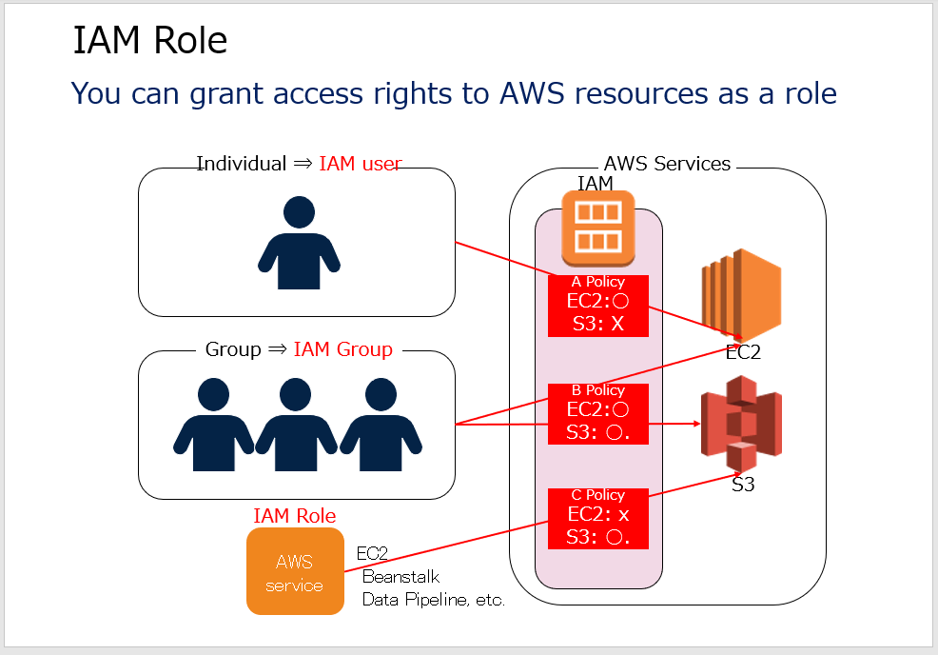
Option 1 is incorrect. You need to configure it on your EC2 instance instead of S3.
Option 2 is incorrect. Setting the IAM role is essential even in the same region.
Option 3 is incorrect. Setting up an IAM role is essential even for the same account.

Question 37: Correct
Select the most likely cause if your SSH connection to your EC2 instance fails.
- ​
Specified the public IP address of the EC2 instance as the SSH connection destination.
- ​
Specified the Elastic IP address of the EC2 instance as the SSH connection destination.
- ​
Specified the Private IP address of the EC2 instance as the SSH connection destination.
(Correct)
- ​
Specified the IPv4 IP address of the EC2 instance as the SSH connection destination.

Explanation
Option 3 is the correct answer. If you specify a private IP address when specifying the IP address of the instance, access will fail because the IP address cannot be determined from the Internet. It is necessary to use a public IP address.
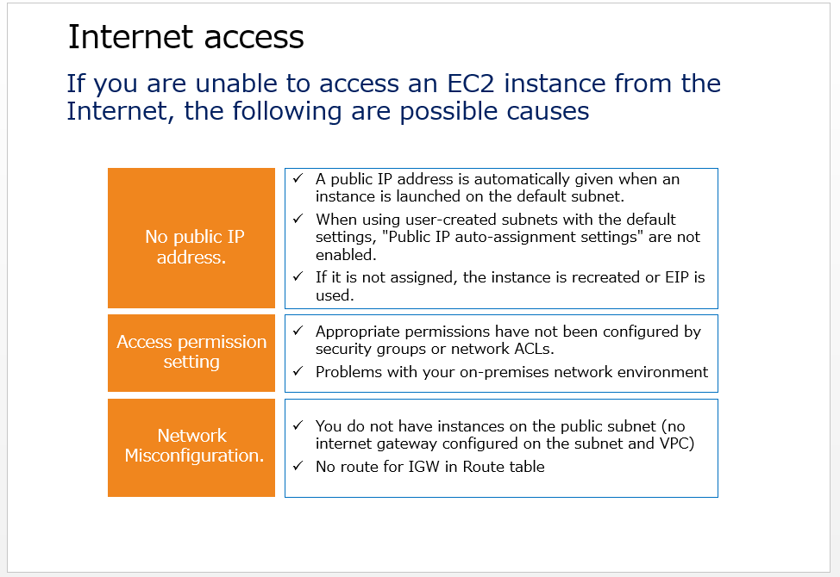
Option 1 is incorrect. There is no problem if you specify a public IP address.
Option 2 is incorrect. You can access it even with an Elastic IP address.
Option 4 is incorrect. It is possible to access using an IPv4 IP address.

Question 38: Incorrect
Which estimation tools are currently available on AWS?
- ​
TCO calculator
- ​
AWS simple monthly calculator
- ​
AWS Cost Explorer
(Incorrect)
- ​
AWS Pricing Calculator
(Correct)

Explanation
Option 4 is the correct answer. From 2021, Currently, it is recommended to use only the AWS Pricing Calculator. AWS Pricing Calculator lets you explore AWS services, and create an estimate for the cost of your use cases on AWS.

Option 1 is incorrect. AWS TCO Calculator has been replaced by the AWS Pricing Calculator. Please have a look at this blog post to learn how you can estimate your EC2 and EBS cost using the new calculator.
Option 2 is incorrect. AWS simple monthly calculator has been replaced by the AWS Pricing Calculator
Option 3 is incorrect. AWS Cost Explorer is not a calculator for AWS Pricing

Question 39: Incorrect
Where is the AWS location where DynamoDB is located and set up?
- ​
AZ
- ​
VPC
- ​
Edge Location
(Incorrect)
- ​
Region
(Correct)

Explanation
Option 4 is the correct answer. DynamoDB is a global service set up in a region.

Question 40: Correct
Select the features available by Trusted Adviser.
- ​
It automatically presents a configuration plan for cost optimization
- ​
It can carry out cost status monitoring
- ​
It can be used to improve security.
(Correct)
- ​
It can detect unauthorized access

Explanation
Option 3 is the correct answer. Trusted Advisor is an online resource that helps you reduce costs, improve performance, and improve security by optimizing your AWS environment. Trusted Advisor provides real-time guidance to help you provision your resources according to AWS best practices. Therefore, Trusted Adviser can improve security.

Option 1 is wrong. Trusted Advisor offers suggestions for improvements, but not suggestions for configurations.
Option 2 is wrong. Trusted Advisor does not perform monitoring
Option 4 is wrong. Trusted Advisor cannot be used to detect unauthorized access.

Question 41: Incorrect
Select one of the following that will reduce costs.
- ​
If you set an Elastic IP address, you will be charged, so you can reduce the cost by detaching it.
- ​
Use a spot instance when setting Auto Scaling for an EC2 instance.
(Correct)
- ​
Minimize the required number of EC2 instances based on performance surveys.
(Incorrect)
- ​
Reduce the number of instances by using a single AZ configuration instead of a multi-AZ configuration.

Explanation
Option 2 is the correct answer. Cost reduction is possible by specifying a spot instance instead of an on-demand instance during Auto Scaling.

Option 1 is incorrect. You will not be charged even if you set an Elastic IP address. The Elastic IP address has a special billing system that is charged when it is not used as it is created.
Option 3 is incorrect. Minimizing the number of EC2 instances, even with Auto Scaling configured, can slow performance with a small load.
Option 4 is incorrect. Single AZ is not recommended as redundant configuration with multi-AZ is required as a best practice.

Question 42: Correct
You are building a web application that will be used globally. Choose a deployment method to load the server for global users.
- ​
Deploy to two or more VPCs in two AZs
- ​
Deploy to multiple AZs in one region
- ​
Deploy to multiple AZs in multiple regions
(Correct)
- ​
Deploy to one AZ

Explanation
Option 3 is the correct answer. If you have users globally, you can decentralize the processing process while ensuring low latency by installing servers located geographically close to each other. To increase the redundancy of web applications that will be deployed globally, you need to use multiple AWS regions.
For maximum redundancy, deploy your application to multiple AZs in multiple AWS Regions. This configuration improves application fault tolerance. Having an infrastructure configuration for each region provides optimal application processing even for geographically distant users. In addition, it can continue to operate in the event of a failure in an AZ within a particular region.

Question 43: Incorrect
Choose the correct description for AWS Systems Manager. (Select three.)
- ​
AWS Systems Manager allows you to check operational data for each resource group such as EC2.
(Correct)
- ​
AWS Systems Manager automates EC2 patches, updates, configuration changes / deletes / stops, and deployments
(Correct)
- ​
AWS Systems Manager specializes in managing AWS resources.
(Incorrect)
- ​
AWS Systems Manager gives you easy visibility into the latest status of your IAM account
- ​
AWS Systems Manager can see data in your on-premises environment
(Correct)

Explanation
Option 1 is the correct answer. With AWS Systems Manager, you can check operational data by classifying it into resource groups such as EC2.
Option 2 is the correct answer. With AWS Systems Manager, you can automate EC2 patches, updates, configuration changes / deletions / stops, and deployments.
Option 5 is the correct answer. AWS Systems Manager can be used for operation management by integrating the on-premises environment and the AWS environment.

Option 3 is incorrect. This is a mistake because AWS Systems Manager can be integrated with your on-premises environment.
Option 4 is incorrect. IAM account management is not included in AWS Systems Manager.

Question 44: Incorrect
Choose the correct description for the Auto-Scaling Launch configurations.
- ​
Sets the minimum and maximum number of instances to launch.
- ​
Selects the scaling method.
(Incorrect)
- ​
Selects the instance type to launch
(Correct)
- ​
Sets the ELB target group.

Explanation
Option 3 is the correct answer. Instance type selection is what you set in Launch configurations.

Option 1 is incorrect. You can set the minimum and maximum number of launch instances in the Auto-Scaling group.
Option 2 is incorrect. Select the scheduling method in the Auto-Scaling group.
Option 4 is incorrect. Set the ELB target group in the Auto-Scaling group.

Question 45: Correct
Choose the correct description of ELB's sticky session feature
- ​
It is a function that distributes the load to EC2 instances deployed in multiple AZs.
- ​
It is a function to stop sending a new request to the backend instance when the instance is unregistered or an error occurs.
- ​
It is a function to send all requests from the same user to the same EC2 instance.
(Correct)
- ​
It is a function to check the normality / abnormality of the EC2 instance and decide which EC2 to use.

Explanation
Option 3 is the correct answer. Sticky session is a function to send all requests from the same user to the same EC2 instance during the session.

Option 1 is incorrect. Load distribution is a function that distributes the load to EC2 instances deployed in multiple AZs.
Option 2 is incorrect. Connection Draining is a function that stops sending new requests to the backend instance when the instance is unregistered or an error occurs.
Option 4 is incorrect. Health check is a function to check the normality / abnormality of EC2 instance and decide which EC2 to use.

Question 46: Correct
Select AWS's Availability Zone connection method when connecting within the same region.
- ​
Low latency link connection
(Correct)
- ​
Connect with Direct Connect
- ​
Connect with VPC endpoint
- ​
Physical direct link

Explanation
Each AWS Region contains several different locations or Availability Zones. Each Availability Zone is independent of the other Availability Zones and is immune to other AZ failures. Availability zones consist of one or more data centers. AZ within a region have a low latency link network connection to other Availability Zones within the same region. This allows data to be replicated synchronously between data centers, allowing failover to be automated. Therefore, a low latency link connection allows you to synchronize your data as much as possible. Option 1 is the correct answer.

Question 47: Incorrect
Choose the action you need to manage as a user, as shown in the AWS shared responsibility model.
- ​
Patch management
- ​
Routing management
(Correct)
- ​
Configuration management
- ​
Awareness & Training
(Incorrect)

Explanation
Option 2 is the correct answer. The setting of routing on the network such as VPC is within the control range on the customer side.

■Inherited Controls
Controls which a customer fully inherits from AWS.
Physical and Environmental controls

■Shared Controls
Controls which apply to both the infrastructure layer and customer layers, but in completely separate contexts or perspectives. In a shared control, AWS provides the requirements for the infrastructure and the customer must provide their own control implementation within their use of AWS services. Examples include:

-Patch Management – AWS is responsible for patching and fixing flaws within the infrastructure, but customers are responsible for patching their guest OS and applications.
-Configuration Management – AWS maintains the configuration of its infrastructure devices, but a customer is responsible for configuring their own guest operating systems, databases, and applications.
-Awareness & Training - AWS trains AWS employees, but a customer must train their own employees.
Therefore, options 1, 3 and 4 are shared controls and are incorrect.

■Customer Specific
Controls which are solely the responsibility of the customer based on the application they are deploying within AWS services.

Question 48: Correct
I want to see if I've achieved cost optimization in using the AWS cloud, but I haven't done any detailed research. Which service should I use to investigate?
- ​
AWS Trusted Advisor
(Correct)
- ​
CloudWatch Alarm
- ​
AWS Config
- ​
AWS Billing and Cost Management

Explanation
Option 1 is the correct answer. By investigating the usage of AWS resources with AWS Trusted Advisor, you can see the improvement points for cost optimization for the AWS resources you are currently using.

Option 2 is incorrect. CloudWatch Alarm is a feature that allows you to set notifications for events.
Option 3 is incorrect. AWS Config is a service that allows you to evaluate, audit, and review AWS resource settings. Config continuously monitors and records your AWS resource settings and can automatically evaluate the recorded settings for your desired settings. AWS Config does not have the ability to evaluate AWS cloud cost optimization.
Option 4 is incorrect. AWS Billing and Cost Management is a service used to pay AWS invoices, monitor usage, and analyze and manage costs.

Question 49: Correct
What are the benefits of using an EC2 instance instead of an on-premises server?
- ​
Improves fault-tolerance
(Correct)
- ​
Data backup and protection can be fully automated.
- ​
AWS performs patch management for the software.
- ​
Improves remote access to the cloud.

Explanation
By using EC2 instances, you can easily build fault-tolerant applications that required complicated settings on your on-premises server. For example, you can improve fault tolerance by installing an ELB to distribute traffic across multiple instances and multiple Availability Zones so that only healthy EC2 instances can receive traffic. Therefore, option 1 is the correct answer.

Option 2 is incorrect. Data backup and protection are not fully automatic and require users to perform data encryption and manual snapshots.
Option 3 is incorrect. Users are required to manage patches for the software used in EC2 instances.
Option 4 is incorrect. Improving remote access to the cloud depends on the external environment and is not a feature of EC2 instances.

Question 50: Correct
Choose a service that provides a set of servers that you can use to build a small website.
- ​
Amazon Lightsail
(Correct)
- ​
Amazon EC2
- ​
Amazon ECS
- ​
Amazon EKS

Explanation
Option 1 is the correct answer. It's best to use Amazon Lightsail rather than an EC2 instance to build small websites and applications. Lightsail is ideal for simpler workloads, faster deployments, and getting started with AWS. Lightsail is a VPS designed to start with small specifications and extend. It's the perfect service to use when building simple web apps and applications.

Option 2 is incorrect. Amazon EC2 is a web service that provides secure, resizable computing performance in the cloud. It's best to use Amazon Lightsail rather than an EC2 instance to build small websites and applications.
Option 3 is incorrect. Amazon Elastic Container Service (Amazon ECS) is a fully managed container orchestration service.
Option 4 is incorrect. Amazon Elastic Kubernetes Service (Amazon EKS) gives you the flexibility to start, run, and scale Kubernetes applications in the AWS cloud or on-premises.

Question 51: Correct
Choose the correct description of IAM features. (Select two.)
- ​
It is possible to realize the integration of multiple AWS accounts.
- ​
Password-less access is possible by using multi-factor authentication
- ​
IAM allows you to customize your password policy
(Correct)
- ​
You can set IAM policies for IAM groups, IAM users, and IAM roles
(Correct)
- ​
You can suspend the permissions of the root account in IAM.

Explanation
Option 3 is the correct answer. You can change your password policy from the IAM console screen. This allows you to change the password setting format that the user should use.
Option 4 is the correct answer. You can grant access to AWS resources by setting IAM policies for IAM groups, IAM users, and IAM roles.

Option 1 is incorrect. It is AWS Organizations that can achieve the integration of multiple AWS accounts.
Option 2 is incorrect. Even if you use multi-factor authentication, you still need a password to log in. After performing password authentication when logging in, enter the MFA code to complete the login.
Option 5 is incorrect. You can remove the access key for the root account and change IAM administrator privileges to the main user, but IAM cannot suspend root account privileges.

Question 52: Correct
Choose a service that provides a hybrid configuration that extends on-premises storage to S3 while making on-premises storage primary.
- ​
AWS Storage Gateway cached volume gateway
- ​
AWS Storage Gateway storage volume gateway
(Correct)
- ​
AWS Storage Gateway File Gateway
- ​
AWS Storage Gateway Tape Gateway

Explanation
Option 2 is the correct answer. The storage type volume can be used for high-speed read access by using the local storage as the primary storage while expanding and linking the storage in the on-premises environment to the S3 storage. In addition to this, it asynchronously copies and maintains volumes stored in Amazon S3 buckets.

Option 1 is incorrect. Cached volumes store the entire volume with an Amazon S3 bucket as the primary storage. The latest access data is kept in the gateway's local cache for low latency access.
Option 3 is incorrect. You can connect to the AWS cloud from your on-premises environment using the AWS Storage Gateway file interface or file gateway. You can store application data files and backup images as durable objects in Amazon S3 cloud storage.
Option 4 is incorrect. The tape gateway provides a backup function using virtual tape.

Question 53: Incorrect
Which service detects unauthorized access in your VPC flow log?
- ​
Amazon Inspector
(Incorrect)
- ​
IAM Access Analyzer
- ​
Amazon GuardDuty
(Correct)
- ​
CloudTrail

Explanation
Option 3 is the correct answer. Amazon GuardDuty is a threat detection service that continuously monitors malicious operations and malicious operations. It mainly analyzes network information such as VPC flow logs to determine threats.

Option 1 is incorrect. Amazon Inspector evaluates AWS-hosted applications to determine exposures, vulnerabilities, best practices, and more. It is an evaluation for applications only.
Option 2 is incorrect. AWS IAM Access Analyzer can analyze unauthorized access such as Amazon S3 buckets and IAM roles that are shared with external entities.
Option 4 is incorrect. CloudTrail can record your AWS account activity history, including actions performed using the AWS Management Console, AWS SDKs and command line tools, and other AWS services.

Question 54: Correct
Choose an AWS service that you can use to integrate your on-premises MS Active Directory with IAM.
- ​
AWS Organizations
- ​
IAM Active Directory
- ​
AWS Directory Service
(Correct)
- ​
AWS Control Tower

Explanation
Option 3 is the correct answer. AWS Managed Microsoft AD makes it easy to extend your existing Active Directory to the AWS cloud. This makes it possible to integrate Active Directory used in the on-premises environment and IAM management and use it for user management.

Option 1 is incorrect. AWS Organizations is a service that integrates and manages multiple AWS accounts. It does not have a function to link with Active Directory.
Option 2 is incorrect. There is no such service.
Option 4 is incorrect. AWS Control Tower is a service that defines security, operations, and compliance rules to help you deploy and use AWS workloads that adhere to those rules.

Question 55: Incorrect
Choose the correct description for the AWS Service Catalog feature.
- ​
It can take a snapshot of the configuration information.
- ​
It can be used for resource change management.
- ​
It provides a list of optimal uses of AWS services.
(Incorrect)
- ​
It can limit the IT services available to users.
(Correct)

Explanation
Option 4 is the correct answer. The AWS Service Catalog allows you to create and manage a catalog of IT services that are approved for use on AWS. You can apply IAM permissions in the AWS Service Catalog to control who can view and modify your products and portfolios. By granting users access to the portfolio, they can use the portfolio to launch products.

Option 1 is incorrect. AWS Service Catalog shares a portfolio of configurations with users, but you can't take snapshots.
Option 2 is incorrect. Use Config for resource change management.
Option 3 is incorrect. Trusted Advisor provides guidance on how to best use AWS services.

Question 56: Correct
Select the acquisition time when acquiring the data saved in Glacier Deep Archive by standard.
- ​
3 to 5 hours
- ​
Within 10 hours
- ​
Within 12 hours
(Correct)
- ​
Within 48 hours

Explanation
Option 3 is the correct answer. The S3 Glacier Deep Archive offers two access options, from 12 hours to 48 hours. Data can be acquired within 12 hours for standard access and within 48 hours for large-capacity access.

Question 57: Incorrect
Select plans that can use all items of Trusted Advisor. (Please select more than one.)
- ​
AWS Support Business Plan
(Correct)
- ​
AWS Support Developer Plan
(Incorrect)
- ​
AWS Support Basic Plan
- ​
AWS Support Enterprise Plan
(Correct)

Explanation
Options 1 and 4 are correct answers. All items of Trusted Advisor is a plan available for business or enterprise support plans. AWS Trusted Advisor provides a full set of Trusted Advisor checks to help you optimize your entire AWS infrastructure.

Option 2 and 3 are incorrect. The Developer Plan and Basic Plan have limited functionality in Trusted Advisor.

Question 58: Incorrect
Please select the wrong description of the AWS Database Migration Service feature.
- ​
Supports the transition from on-premises databases to RDS.
- ​
Supports the transition from RDS to on-premises databases.
- ​
Supports the transition from RDS to EC2 database servers.
(Incorrect)
- ​
Supports the transition from RDS to Redshift.
- ​
Supports the transition from RDS to Aurora.
(Correct)

Explanation
Option 5 is the wrong explanation, so it is the correct answer. Migrating from RDB to Aurora is easily accomplished by using RDS snapshots.
AWS Database Migration Service (AWS DMS) is a service for migrating relational databases, data warehouses, and NoSQL databases. You can use this to migrate between databases in on-premises environments, AWS database services such as RDS and Redshift, and databases installed on EC2.
You can also migrate from RDS to Redshift and EC2 MySQL to RDS.

Question 59: Incorrect
Your company needs to manage the accounts of 100 AWS users. Which setting should you make?
- ​
Set up an IAM group for each department and assign IAM users to this group.
(Correct)
- ​
Set an IAM role for each department and assign IAM users to this role.
(Incorrect)
- ​
Assign member accounts to users using AWS Organizations.
- ​
Assign individual IAM policies to IAM users.

Explanation
Option 1 is the correct answer. If you want to set access rights to AWS resources for multiple users, you need to use IAM to manage access. When managing a large number of users, it is inefficient to apply IAM policies to individual IAM users. The best way to manage it is to create IAM groups with the appropriate permissions for each department and assign IAM users to those groups.

Option 2 is incorrect. The IAM role is a feature that grants access to AWS resources.
Option 3 is incorrect. AWS Organizations is a service that manages multiple AWS accounts. It is not available for individual user management.
Option 4 is incorrect. Assigning individual IAM policies to 100 IAM users is inefficient. In this scenario, you need to set an IAM policy on a per IAM group basis.

Question 60: Correct
You need to visualize and report on AWS cost spending. Which service should you use?
- ​
Cost Categories
- ​
AWS Billing alarm
- ​
TCO calculator
- ​
Cost Explorer
(Correct)

Explanation
Option 4 is the correct answer. Cost Explorer is a tool you can use to view and analyze costs and usage. You can use the main graph and cost and usage reports, or the Cost Explorer report to create a report on the usage and cost of AWS resources in your account.

Option 1 is incorrect. Cost Categories is a service that allows you to manage costs by dividing them into arbitrary projects or organizations. It is not a tool used for cost visualization and analysis.
Option 2 is incorrect. AWS Billing alarm is a setting that alerts you by e-mail etc. when the billing value reaches the set value. It is not a tool used for cost visualization and analysis.
Option 3 is incorrect. The TCO calculation tool is an estimation tool used to compare the usage cost of AWS with the on-premises environment. It is not a tool used for cost visualization and analysis.

Question 61: Incorrect
You are considering a database suitable for managing and utilizing a large number of JSON files. Choose the best AWS service.
- ​
RDS
- ​
Aurora
(Incorrect)
- ​
EFS
- ​
DynamoDB
(Correct)

Explanation
Option 4 is the correct answer. DynamoDB can be used as a document database that stores and processes JSON format data. DynamoDB is also available as a document DB and provides native support for JSON documents. This allows DynamoDB to store semi-structured data such as Tags. With DynamoDB, you can get data from within JSON documents and perform operations at high speed.

Options 1 and 2 are incorrect. RDS and Aurora are relational databases provided as managed services. Not suitable for saving JSON files.
Option 3 is incorrect. EFS is file storage. It is possible to save the JSON file, but it does not meet the requirements because it is not a database.

Question 62: Correct
Choose a support service that provides quick response to invoice and account questions.
- ​
Amazon Trusted Advisor
- ​
Concierge support
(Correct)
- ​
AWS Service desk
- ​
AWS Support Center

Explanation
Option 2 is the correct answer. Concierge Support, included in AWS Support's Enterprise Support Plan, is a service that responds quickly and efficiently to user bills and account inquiries. Senior customer service professionals who are familiar with users and their accounts will answer each user's questions. Specifically, they can help in the following ways.
・24x7 access to AWS billing and account inquiries.
・Providing guidance and best practices for billing allocation, reporting, account consolidation, and root-level account security
・ Payment inquiries · Providing training on specific cost reports
・ Support for service restrictions
・ Support for bulk purchases

Option 1 is incorrect. AWS Trusted Advisor is an online tool that assesses the use of AWS resources according to AWS best practices and provides real-time guidance. You can take advantage of this to improve security and performance, reduce total costs, and monitor service limits. AWS Trusted Advisor is a tool, so staff don't answer questions personally.
Option 3 and 4 are incorrect. There are no services such as AWS Service desk or AWS Support Center.

Question 63: Correct
Choose the correct description of the reliability principle, one of the basic principles of the Well Architected Framework.
- ​
Shared model of security measures
- ​
Cost optimization
- ​
Early recovery from failure
(Correct)
- ​
Highly secure system

Explanation
Reliability is the principle of ensuring that the system can be used continuously without problems. Reliability is also "disability endurance" and is an indicator of the frequency and intervals at which systems and services become unavailable. Reliability includes the ability of the system to recover from infrastructure or service interruptions, dynamically acquire computing resources on demand, and mitigate interruptions such as misconfigurations and temporary network problems. To increase reliability, redundant system configurations must enable early recovery from failures. Therefore, option 3 is the correct answer.

Question 64: Correct
You want to use EC2 instances for a long period of 3 years or more, but you need to be able to exchange instance sizes along the way. Choose the cheapest instance type that meets this requirement.
- ​
Reserved Instance (Convertible )
- ​
Reserved Instance (Scheduled)
- ​
Reserved Instance (Standard)
(Correct)
- ​
Reserved Instance (Elastic )

Explanation
Reserved Instance (Standard) can change the following attributes.
-Availability zone or scope
-Network platform (EC2-Classic or VPC)
-Instance size (Linux only)

On the other hand, Reserved Instances (Convertibles) can also be replaced with one or more other Convertible Reserved Instances with different configurations for instance families, operating systems, and tenancy.
There is no limit to the number of exchanges that can be performed as long as the exchanged convertible reserved instance has a value equal to or greater than the exchanged convertible reserved instance.
Since the contents that can be changed in the standard are limited, the discount rate is higher due to the lower flexibility. Therefore, option 3 is the cost-optimal instance.

Option 1 is incorrect. Reserved Instances (Convertibles) are more flexible, but offer lower discount rates than Standard.
Option 2 is incorrect. Scheduled Reserved Instances have a lower discount rate than Standard Reserved Instances, but you can save money even at low occupancy rates. And then, Scheduled Reserved Instances are no longer available from 2021.
Option 4 is incorrect. Elastic Reserved Instances do not exist.

Question 65: Incorrect
Choose the feature that AWS Snowball Edge offers.
- ​
Mass data migration by a trailer
- ​
It stores 100TB of data
(Incorrect)
- ​
It can perform machine learning.
(Correct)
- ​
It can launch a Lambda edge.

Explanation
AWS Snowball Edge is a data migration and edge computing device with two options. The first is Snowball Edge Storage Optimized, which provides computing with 24 vCPUs applied to both block storage and Amazon S3 compatible object storage. This is ideal for large data transfers.

The second option is Snowball Edge Compute Optimized, which can perform advanced machine learning and full-motion video analysis in disconnected environments, and offers 52 vCPUs, block and object storage, and an optional GPU.
Snowball Edge can run EC2 AMIs and deploy AWS Lambda code, allowing you to run machine learning and applications on your device for data processing and analysis locally. Therefore, option 3 is the correct answer.

Option 1 is incorrect. Mass data migration with trailers is provided by Snowmobile. AWS Snowmobile is an exabyte-scale data transfer service that can be used to move very large amounts of data to his AWS.
Option 2 is incorrect. Snowball Edge Storage Optimized has 100TB of storage, but the available data area is up to 80TB. Snowball Edge Compute Optimized can store 42TB of data. Both cannot store 100TB of data.
Option 4 is incorrect. Lambda @ Edge is a function that works with Cloudfront running at the edge location.

